
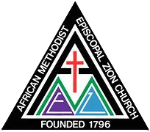
African Methodist Episcopal Zion Church
South Atlantic Episcopal District
Palmetto Conference
Columbia-Camden District

Bishop Eric Leake Rev. Dr. Alvin W. McLamb
Presiding Bishop Presiding Elder

Report of the State of the Church

District Conference held at Click or tap here to enter text. A.M.E. Zion Church on Click or tap to enter a date.
__________________________________________________________________________

Click or tap here to enter text.

Respectfully submitted: Click or tap here to enter text.

Committee Members

